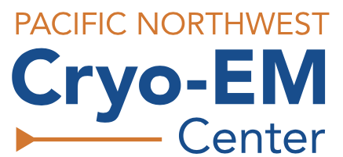
PACIFIC NORTHWEST
CRYO-EM CENTER
Mail code CL-P2M
2730 S.W. Moody Ave.
Portland, OR 97201

Proposal Guidelines
General Access awards may remain active for up to 2 year and are eligible up to 480 hours of microscope time per year. Initial allocations are based on external peer review guidance. Subsequent allocations are provided upon request and require progress update. Awarded allocations expire after 6 months. Upon completion of a General Access award, investigators must submit a new proposal.

Proposals submitted by 11:59 PM Pacific Time on the 1st of each month will be sent for peer review that month. Submissions received after that date will be sent for review on the following month.

Research Plan (3-page max, including figures)
Establish context for the proposed research and detail the planned experimental approach using typical NIH format (e.g., 12pt Times New Roman or 11pt Arial Font, 0.5” border). Please include the following sections: Specific Aims, Significance, Preliminary Results, Experimental Approach and Training Goals, as appropriate. Include references where relevant and attach the full list of citations in appropriate section below. Additional supplemental data/appendix will not be accepted.

- Specific Aims
State the specific objectives of the research proposed, providing concise details (200 words or less).

- Significance
Concise background discussion of previous work should make it clear what the research problem is and its significance (250 words or less).

- Preliminary Results (as applicable)
Provide preliminary data (embedded figures optional) that demonstrate the feasibility and/or sample readiness for the aims of the project; such as SDS-PAGE gels, SEC traces, preliminary negative stain or cryo-EM images, etc. Label all figures and provide a brief description as appropriate.

- Experimental Approach
Describe the work to be conducted at PNCC during the awarded project period. For each aim and/or sample under investigation, provide a detailed description of the experiment(s) to be performed (e.g., specimen screening, single particle data collection, tomographic data collection, etc.) and expected outcomes. This section should also include a justification for specific instruments requested (Krios, Arctica, K2/K3, Falcon III, Phase Plate, etc), if any, and for the estimated allocation of time for each experiment. Strength of justification can affect the overall science and resource scores.

- Training Goals (as applicable)
If member(s) of the team will require onsite training, provide a brief description of their past experience with EM or cryo-EM (if any) and their desired training outcomes.

Citations
Include references or citations for research plan.

Biosketches (PI and Co-PI required)
Include NIH formatted biosketch for the principle investigator and co-investigators (if any) on this project. Biosketches for other personnel (e.g., students, staff, postdocs) are not required.

